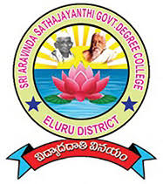 | 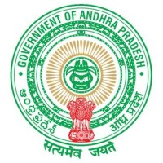 | S.A.S.GOVERNMENTDEGREECOLLEGE  NARAYANAPURAM,ELURU DISTRICT-534406  (AFFILIATEDTOADIKAVINANNAYAUNIVERSITY,RAJAMAHENDRAVARAM)  Phone:08818252189,E-mail:narayanapuram.jkc@gmail.com | 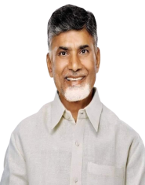 | 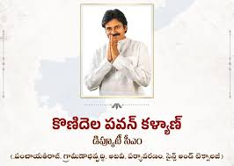
DEPARTMENT OF COMMERCE
[FIELD TRIP ON 07/01/2026 AT MARID MILLI AND RAMPACHODAVARAM]
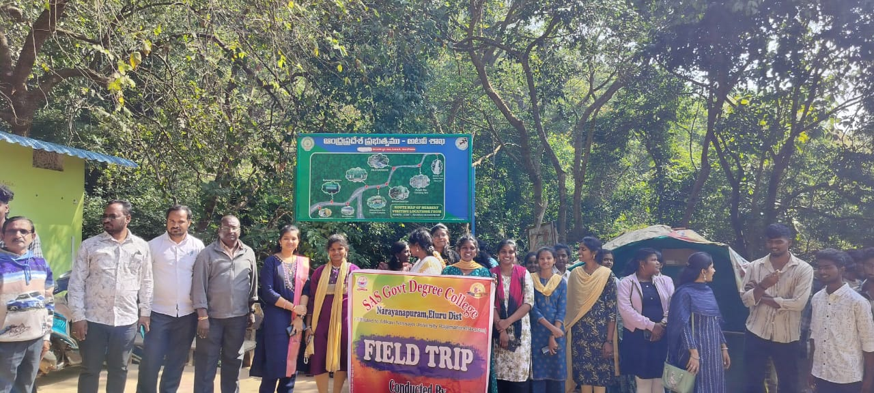
FIELD TRIP REPORT
2025-26

 |  |  | 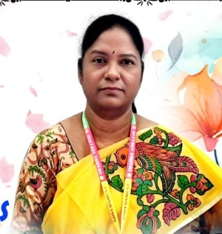
Dr. Narayana Bharath Gupta,IAS.  A.P COMMISSIONER OF COLLEGIATE EDUCATION |  |  | DR.K.VASUDHA GARU  PRINCIPAL  SAS GDC NRPM
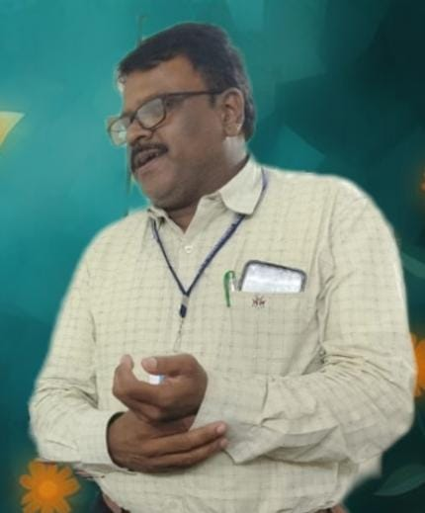 | 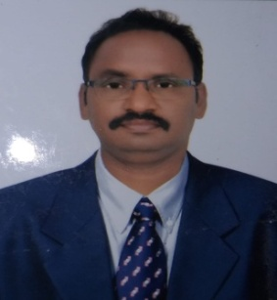 | 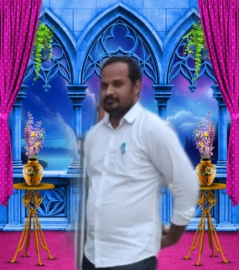 |  | 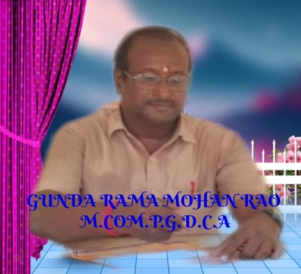 | 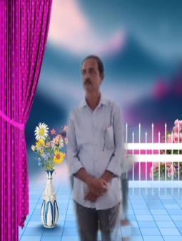 | 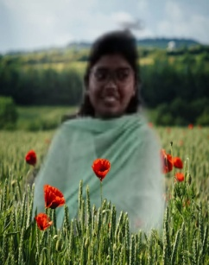
SRI.D.REDDIAH GARU  VICE – PRINCIPAL  SAS GDC NRPM | DR.KONDA RAVI GARU  ACADEMIC COORDINATOR  SAS GDC NRPM | DR.B.VENKATESWARLU REDDI GARU |  | SRI GUNDA RAMA MOHAN RAO  HEAD DEPARTMENT OF COMMERCE  SAS GDC NRPM | SRI.S.V.RAGHU NATH GARU  LECTURER IN COMMERCE | KUM.YASHITA GARU  LECTURER IN COMPTER SCIENCE
FIELD TRIP ADVISERS AND ORGANIZERS

STUDENT REPRESENTATIVES FOR FIELD TRIP
SL.NO | STUDENT NAME | GROUP | IMAGE
1 | T.SANTHOSH | II B.COM | 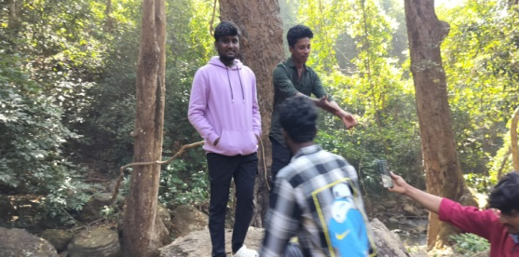
2 | I.SYAM KUMAR | II .B.COM
3 | I.PUSHPA LATHA | II. BCOM | 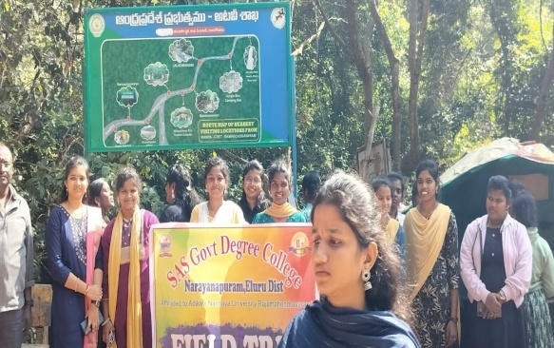
4 | SNEHA | II BZC
5 | SWAPNA | II B.COM
OBJECTIVE: The objective of the field trip to Maredumilli and Rampachodavaram is to provide practical exposure and experiential learning for B.Com and other students beyond the classroom. The visit helps students understand eco-tourism, tribal economy, sustainable development, and the role of natural resources in regional growth. It aims to link theoretical knowledge with real-life observations, enhance environmental awareness, and promote social responsibility among students while encouraging teamwork, discipline, and learning through direct experience.

MINUTES OF THE DEPARTMENTAL MEETING
Date: 05-01-2026
Time: 4PM
Venue: Department of Commerce
Head of the Department
SRI GUNDA RAMA MOHAN RAO
Faculty Members
SMT I LAVANYA
SRI S.RAGHU NADH
Agenda:
To discuss and approve the proposal for conducting a field trip for students.
RESOLUTION:
The department has discussed the importance of experiential learning and practical exposure for students. It is hereby resolved to organize an educational field trip to Maridumilli and Rampachodavaram surroundings for II and I year B.Com students.
THE OBJECTIVES OF THE FIELD TRIP ARE:
To provide real-time exposure to rural economy and tribal markets
To understand eco-tourism and sustainable business practices
To observe local trade, forest-based livelihoods, and small-scale industries
To enhance students’ practical knowledge beyond classroom learning
IT IS FURTHER RESOLVED THAT:
The trip will be conducted during the month of [Insert Month]
Necessary permissions from the Principal will be obtained
Budget estimation and student contribution will be finalized
Safety measures and guidelines will be strictly followed
All faculty members have unanimously approved this proposal.
Action Plan:
Preparation of student list and consent forms
Arrangement of transport and accommodation (if required)
Scheduling academic activities during the trip Signature
Assigning responsibilities to faculty members Head of the Department
Conclusion: Department of Commerce
The meeting concluded with a vote of thanks by the Head of the Department. STAFF 1. :
2.

REQUEST LETTER FOR PRINCIPAL PERMISSION
From
The Department of Commerce
SAS Government Degree College
N.R. P.M.
To
The Principal
SAS Government Degree College
N.R. P.M.

Respected Madam,
Subject: Request for Permission to Organize Academic Visit to Maredumilli and Rampachodavaram
We, the faculty members of the Department of Commerce, respectfully submit this request seeking your kind permission to organize an academic visit for the students of the Department of Commerce to Maredumilli and Rampachodavaram. The proposed visit is intended to provide practical exposure and field-based learning related to environmental resources, tribal economy, eco-tourism, and regional development.
Such an educational tour will help students to understand real-life applications of commerce concepts, rural markets, sustainable development practices, and socio-economic conditions of tribal regions. It will also enhance their observational skills, awareness, and academic interest beyond classroom learning.
Therefore, we kindly request you to grant permission for conducting this academic visit on a suitable date as per the college schedule. We assure you that all necessary precautions, discipline, and safety measures will be strictly followed during the tour.
We shall be highly thankful to you for your kind consideration and support.
Thanking you,
Yours obediently,

Head / Faculty In-charge
Department of Commerce
SAS Government Degree College
N.R. P.M.

FROM
THE PRINCIPAL
SAS GDC NRPM
ELURU DIST
Date: 06-01-2026
To
The Head
Department of Commerce
SAS GDC,NRPM
Subject: Permission Granted for Educational Field Trip to Maridumilli and Rampachodavaram
Ref: Your letter requesting permission to conduct a field trip
With reference to your request, permission is hereby granted to organize an educational field trip to Maridumilli and Rampachodavaram surroundings for the students of II & III B.Com and B.Sc.
You are permitted to proceed with the arrangements subject to the following conditions:
- Prior written consent must be obtained from parents/guardians of all participating students.
- Adequate number of faculty members should accompany the students for proper supervision.
- All necessary safety measures must be strictly followed throughout the trip.
- Proper discipline should be maintained by all students during the journey.
- The trip should be conducted without disturbing regular academic activities as far as possible.
- A detailed report of the field trip should be submitted after completion.
The Department is instructed to ensure smooth conduct of the program and take full responsibility for the safety and well-being of the students.

Principal

DEPARTMENT OF COMMERCE
SAS GDC,NRPM
Date: 07/01/2026]

CIRCULAR
All the students of II & I B.Com and B.Sc are hereby informed that the Department of Commerce is organizing an Educational Field Trip to Maridumilli and Rampachodavaram surroundings.
Details of the Field Trip:
Place: Maridumilli & Rampachodavaram
Date of Journey: 07/01/2026
Time of Departure: 7.30AM
Time of Return: 4.30PM
Objectives of the Field Trip:
- To understand rural economy and tribal livelihoods
- To study eco-tourism and sustainable practices
- To observe local business activities and forest-based occupations
- To gain practical exposure beyond classroom learning
Instructions to Students:
- Students must submit a parental consent letter before [Last Date].
- Maintain discipline and follow instructions of faculty members.
- Carry valid ID cards, necessary personal items, and medicines if required.
- Students should report at the college campus on time.
- Any damage or misconduct will be viewed seriously.
Interested students are requested to register their names with the concerned faculty on or before [Last Date].
Faculty In-charge
Head of the Department
Department of Commerce
Principal

BRIEF NOTE ON FIELD TRIP
Maridumilli and Rampachodavaram Surroundings
1. Activity:
The Department of Commerce organized an educational field trip to Maridumilli and Rampachodavaram surroundings for II & III B.Com and B.Sc students. The trip focused on providing experiential learning by exposing students to rural economy, tribal lifestyles, eco-tourism practices, and local business activities.
2. Aims:
- To bridge the gap between theoretical knowledge and practical exposure
- To enhance students’ understanding of real-world economic activities
- To promote experiential and participative learning
- To create awareness about sustainable development and eco-tourism
3. Objectives:
- To study rural and tribal economic systems
- To observe forest-based livelihoods and small-scale businesses
- To understand eco-tourism and its impact on local communities
- To analyze marketing practices in rural areas
- To develop observational and analytical skills among students
4. Procedure:
- Obtained prior permission from the Principal
- Collected consent letters from students and parents
- Planned itinerary and arranged transportation
- Assigned faculty members for supervision
- Conducted on-site observation, interaction with local people, and data collection
- Guided students to record their observations and prepare reports
5. Outcomes:
- Students gained practical knowledge of rural and tribal economy
- Improved understanding of eco-tourism and sustainable practices
- Enhanced analytical, communication, and observational skills
- Developed awareness of local business and livelihood patterns
- Encouraged students to relate classroom concepts with real-life situations

STUDENTS LIST FOR FIELD TRIP
SL.NO | I B.COM | P/A | SL.NO | II B.COM | P/A | SL.NO | II B.SC [ZOOLOGY] | P/A
1 |  |  | 1 |  |  | 1
2 |  |  | 2 |  |  | 2
3 |  |  | 3 |  |  | 3
4 |  |  | 4 |  |  | 4
5 |  |  | 5 |  |  | 5
6 |  |  | 6 |  |  | 6
7 |  |  | 7 |  |  | 7
 |  |  | 8 |  |  | 8
 | I B.SC |  | 9 |  |  | 9
 |  |  | 10 |  |  | 10
 |  |  | 11 |  |  | 11
 |  |  | 12 |  |  | 12
Signature of the staff
1.
2.
3.
4.
5.

INSTRUCTIONS TO THE STUDENTS
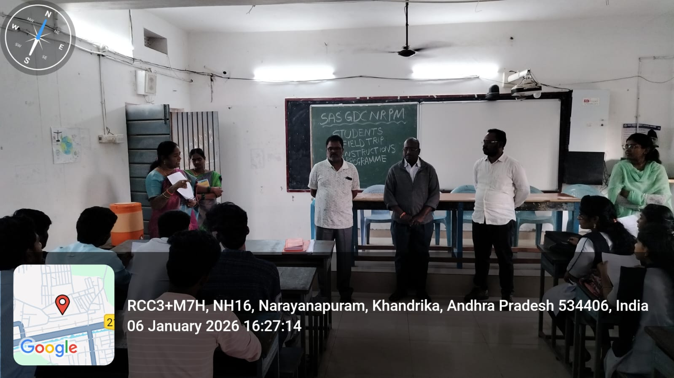 | 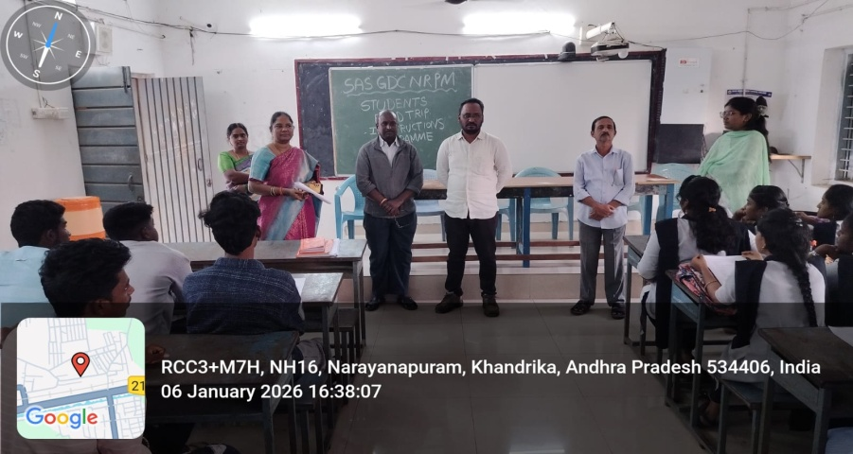
INSTRUCTIONS BY THE HON’BLE PRINCIPAL MADAM  All B.Com students participating in the field trip to Maredumilli and Rampachodavaram must maintain strict discipline and follow college rules throughout the journey. Students should respect nature, local culture, and tribal communities. Safety is the highest priority; therefore, students must not move alone or enter restricted forest or waterfall areas. Proper conduct will reflect the reputation of the college.  INSTRUCTIONS BY THE HON’BLE IQAC COORDINATOR  The field trip is an academic activity aimed at experiential learning. Students are instructed to observe eco-tourism practices, local economic activities, and sustainability measures carefully. Notes should be maintained for academic reporting and internal assessment purposes. Students must actively participate and cooperate with faculty members during learning sessions. | INSTRUCTIONS BY THE HON’BLE ACADEMIC COORDINATOR  Students should report on time at the departure point and strictly follow the schedule prepared for the trip. Carry necessary essentials such as ID cards, notebooks, water bottles, and light food. Avoid wastage of food and ensure cleanliness at all locations visited. Any health issues should be informed to faculty in advance.  INSTRUCTIONS BY THE HEAD, DEPARTMENT OF COMMERCE  B.Com students are expected to relate field observations to commerce subjects such as tourism management, rural markets, entrepreneurship, and sustainable business practices. Group discussions and interactions should be meaningful and academic in nature. Students must submit a field trip report after returning, reflecting their learning outcomes from Maredumilli and Rampachodavaram.

FIELD TRIP STARTING POINT AT THE COLLEGE CAMPUS
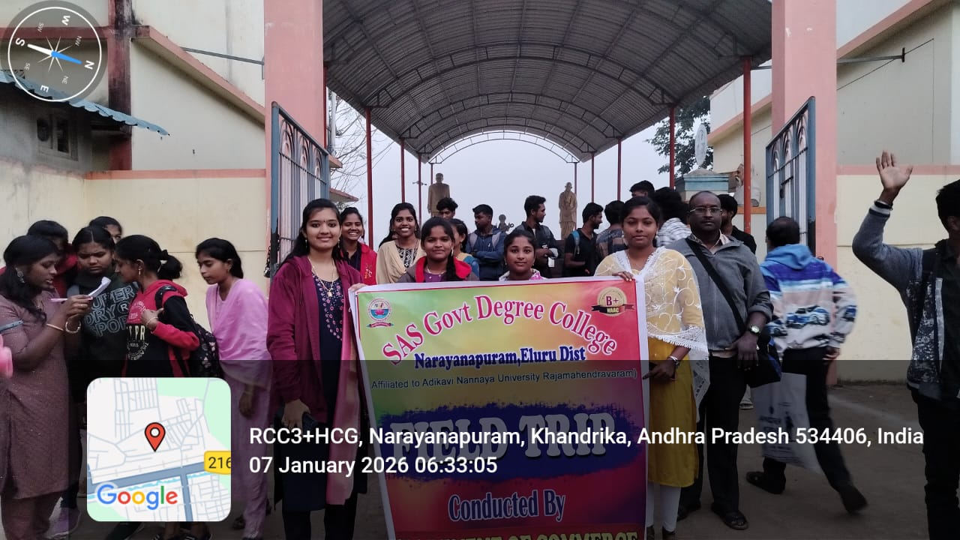 | 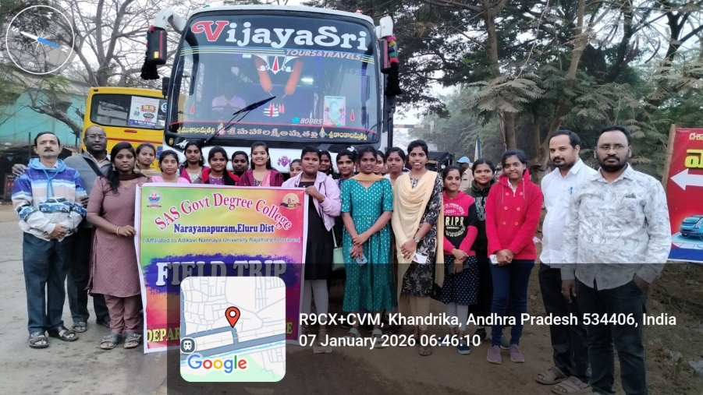
The field trip starting point at the college campus marked the beginning of an exciting and educational journey for the students. Early in the morning, students gathered with enthusiasm, carrying their essentials and academic materials. Faculty members verified attendance, checked safety arrangements, and briefed students about the schedule and objectives of the field trip. The atmosphere reflected discipline, coordination, and eagerness to learn beyond the classroom.
Before departure, important instructions were given regarding safety, time management, and responsible behavior during the trip. Students interacted with peers and teachers, strengthening teamwork and unity. The starting point symbolized not just the physical beginning of the journey, but also the start of experiential learning, practical exposure, and memorable academic exploration for the students.

ON THE WAY OF FIELD TRIP
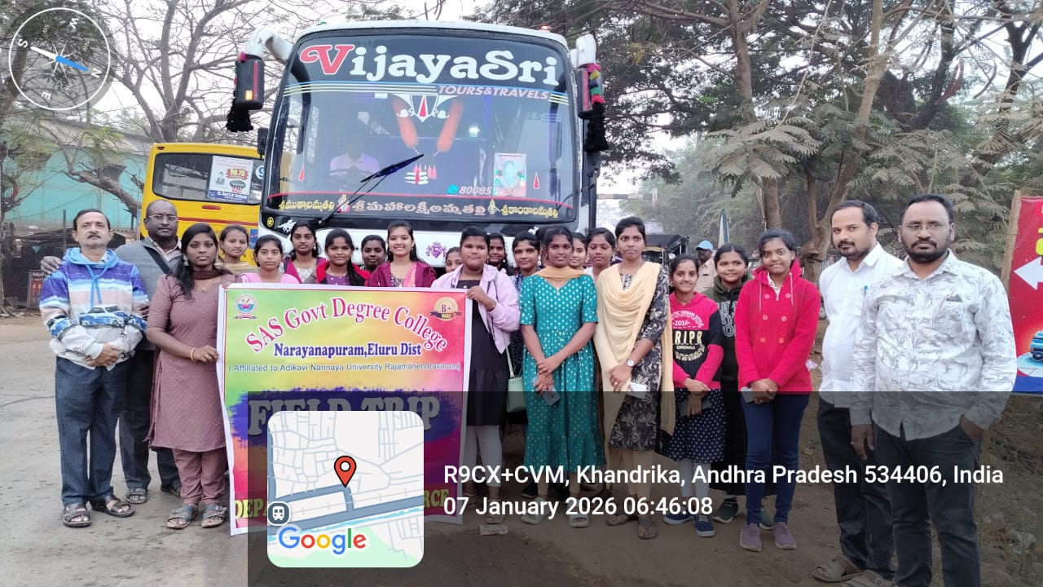 | 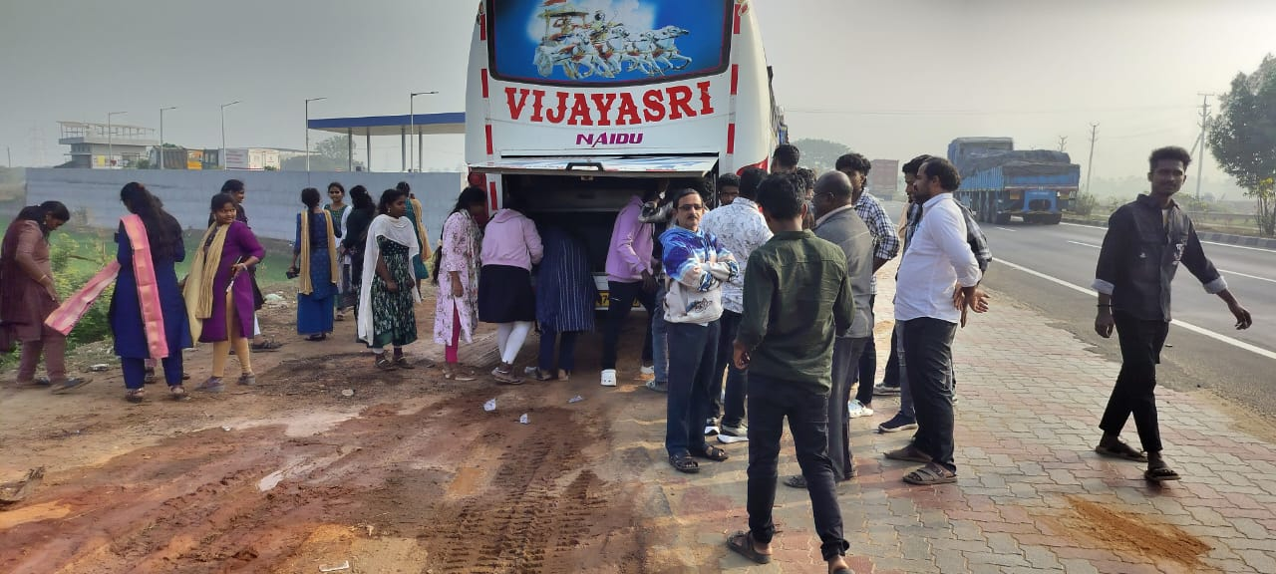
During the field trip to Maredumilli and Rampachodavaram, students doing tiffins on the way became a meaningful and practical learning experience beyond the classroom. Simple food items prepared and shared by students promoted teamwork, planning, and time management. It also encouraged self-reliance and mutual cooperation among the group while traveling through forest and hilly regions.
This activity helped students understand basic concepts of cost control, resource utilization, hygiene, and waste management, which are important for academic and real-life learning. Sharing tiffins reduced dependency on commercial outlets and supported eco-friendly travel by minimizing plastic waste. Overall, doing tiffins on the way strengthened bonding among students and added value to the educational field trip to Maredumilli and Rampachodavaram.

RAMPA WATER FALL AT RAMPACHODAVARAM
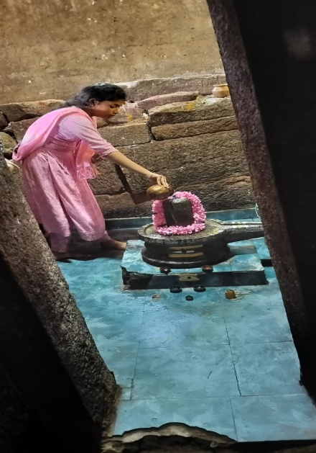 | 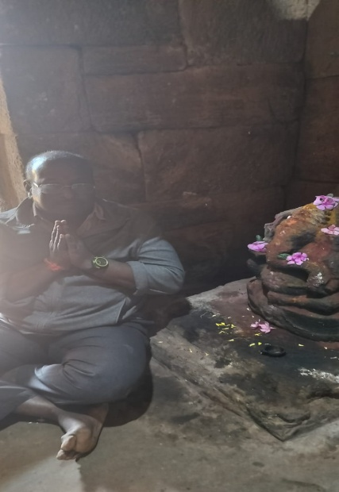 | 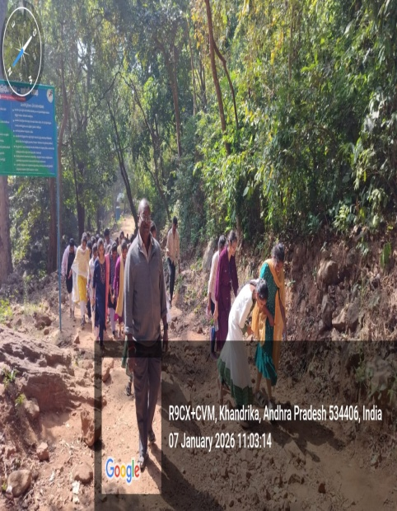 | 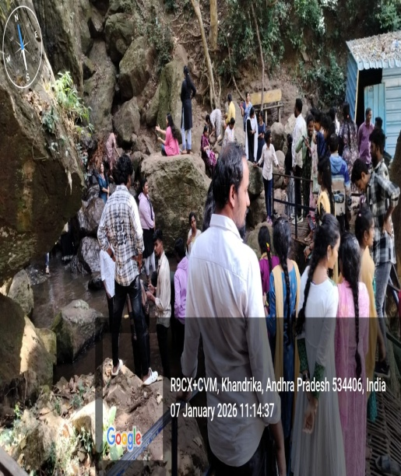
HERE IS A SHORT DEVOTIONAL STORY SET AT RAMPA WATERFALL, RAMPACHODAVARAM, SUITABLE FOR CULTURAL PROGRAMS OR COLLEGE MAGAZINES:
At the serene Rampa Waterfall near Rampachodavaram, where the forest echoed with the sound of flowing water, Nilakanta Swamy (Lord Shiva) once chose to meditate in deep silence. The cool mist of the waterfall covered the sacred rocks, and the tribal people believed that Shiva’s presence protected their land. As Nilakanta Swamy sat in meditation, the entire forest became calm, and nature itself bowed before him.
One day, Vinayakudu (Lord Ganesha) came to Rampa Waterfall to seek his father’s blessings. Seeing the devotion of the local people and the purity of the place, Vinayakudu decided to remove their obstacles and bless them with prosperity. Pleased with Ganesha’s devotion, Nilakanta Swamy opened his eyes and granted a divine blessing, declaring that the waterfall would remain a sacred place of peace and strength. Since then, the people of Rampachodavaram believe that worshipping Nilakanta Swamy and Vinayakudu at Rampa Waterfall brings harmony, courage, and success in life.

BREIF STORY ABOUT MARID MILLI AND RAMPACHODAVARAM

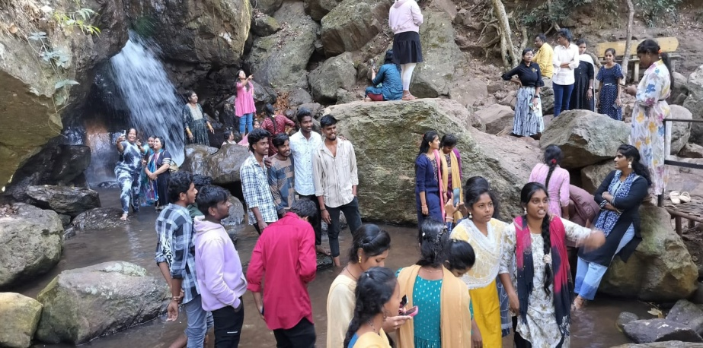
Rampachodavaram is a picturesque tribal region located in the Alluri Sitarama Raju district of Andhra Pradesh. Surrounded by dense forests and hills of the Eastern Ghats, it is known for its natural beauty and rich tribal culture. The area is home to several indigenous tribes who follow traditional customs and livelihoods. Rampachodavaram played an important role during the freedom struggle, especially in the Rampa Rebellion led by Alluri Sitarama Raju. Agriculture, forest produce, and small-scale activities form the backbone of the local economy. The region is also famous for its waterfalls, streams, and pleasant climate. Despite modernization, Rampachodavaram still preserves its cultural heritage and close connection with nature.
Maredumilli is a serene eco-tourism destination near Rampachodavaram, popular for its lush green forests and peaceful environment. It is well known for attractions like Jalatarangini waterfalls, Amruthadhara waterfalls, and dense bamboo groves. The area promotes eco-friendly tourism while protecting wildlife and forest resources. Tribal communities here live in harmony with nature and contribute to forest conservation. Maredumilli offers visitors a chance to experience unspoiled natural beauty and traditional lifestyles. It is an ideal place for nature lovers, trekkers, and students of environmental studies. Together, Rampachodavaram and Maredumilli represent the rich natural and cultural wealth of the Eastern Ghats region.

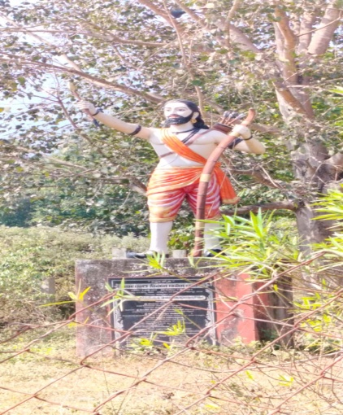 | Deep in the dense forests of Maredumilli, where tall trees whispered secrets of freedom, Alluri Sitarama Raju walked fearlessly among the tribal people. He lived like one of them, shared their hardships, and understood their pain under oppressive colonial forest laws. To the tribes, Raju was not just a leader but a protector who respected their culture and dignity.  From Rampachodavaram, Raju organized resistance with courage and wisdom. Using the hills, rivers, and forests as allies, he led the famous Rampa Rebellion, inspiring unity and bravery among the people. Even when danger surrounded him, his spirit never weakened. The forests of Maredumilli and Rampachodavaram still echo his message—that freedom is born from sacrifice, justice, and unwavering love for the motherland.
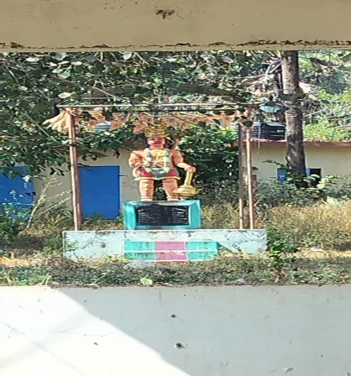 | The Hanuman statue at Rampa Waterfall, near Rampachodavaram, stands as a powerful symbol of devotion, strength, and protection amidst the dense forests of the Eastern Ghats. Surrounded by cascading waters and rocky terrain, the statue creates a spiritual atmosphere that attracts devotees, tourists, and locals alike. Many believe that Lord Hanuman safeguards travelers and the tribal villages in the region.  According to local belief, the presence of Hanuman at Rampa Waterfall represents courage, loyalty, and selfless service. Devotees offer prayers seeking strength, fearlessness, and success before beginning their journey through the forest paths. The calm sound of the waterfall combined with the divine presence of Hanuman makes the place sacred and peaceful. Over time, the Hanuman statue has become both a spiritual landmark and a cultural symbol of Rampachodavaram, blending natural beauty with deep faith

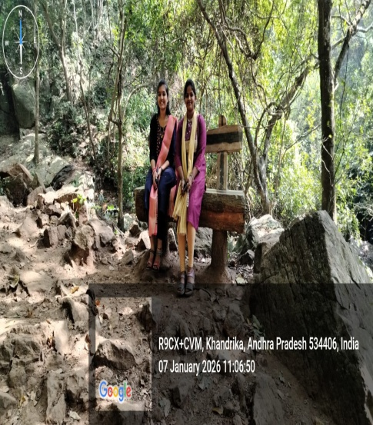 | 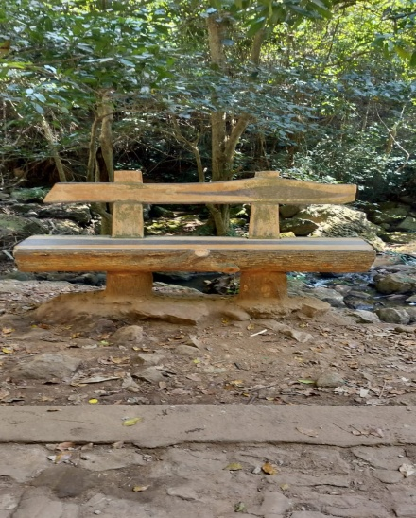 | 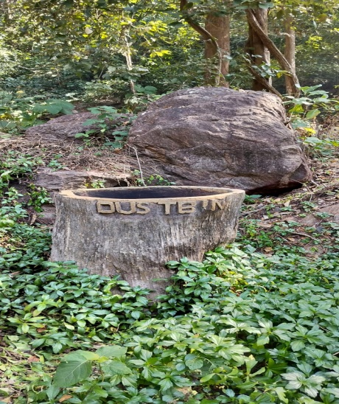 | 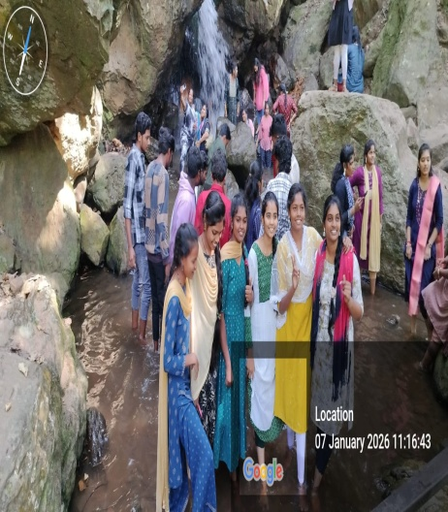
The wooden dustbins and wooden benches at Rampa Waterfall, Rampachodavaram serve as practical learning models for B.Com students in understanding sustainable business practices and environmental responsibility. Made from locally available wood and designed in an eco-friendly manner, these facilities highlight the importance of using renewable resources in public infrastructure. They demonstrate how natural materials can be effectively used while maintaining harmony with the environment.
For B.Com students, these wooden dustbins and benches provide insights into eco-tourism management, cost-effective production, local entrepreneurship, and value addition to forest resources. Students can observe concepts such as sustainable supply chains, community-based enterprises, and maintenance economics in real-life settings. The initiative also emphasizes social responsibility in commerce by promoting cleanliness, visitor comfort, and environmental awareness. Thus, the wooden installations at Rampa Waterfall act as living examples of how commerce and sustainability can work together for regional development.

AMRUTHA DHARA WATER FALL AT MARID MILLI
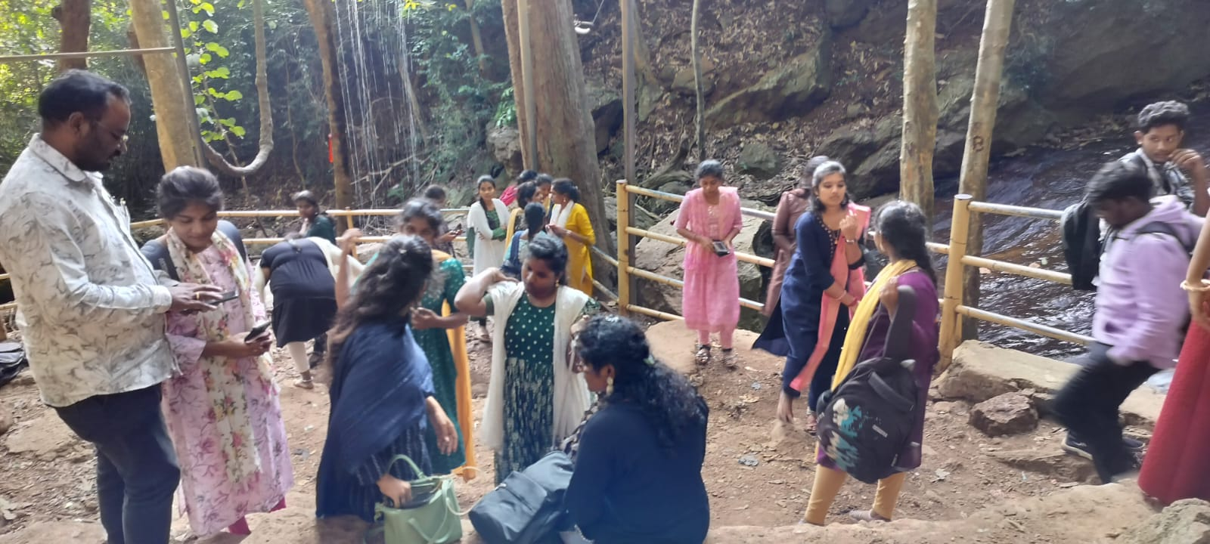 | Nestled deep in the lush green forests of Maredumilli, AMRUTHA DHARA WATERFALL flows like a silver ribbon of life, spreading freshness and calm all around. Surrounded by tall trees and rocky hills, the waterfall is believed to be a blessing of nature, offering peace to weary travelers and joy to the local people. The gentle sound of falling water blends with the songs of birds, creating a soothing and divine atmosphere.  According to local belief, AMRUTHA DHARA WATERFALL symbolizes purity and renewal. Visitors feel refreshed as if nature itself washes away their worries. Students and tourists who visit the waterfall learn the importance of protecting such natural treasures. Over time, Amrutha Varshini Waterfall has become not only a scenic attraction but also a symbol of harmony between humans and nature in the heart of Maredumilli.
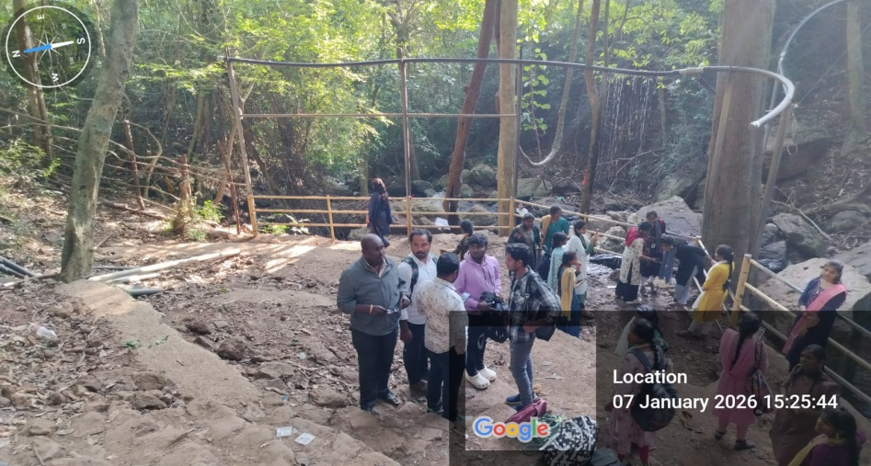

AMRUTHA DHARA WATERFALL AT MAREDUMILLI
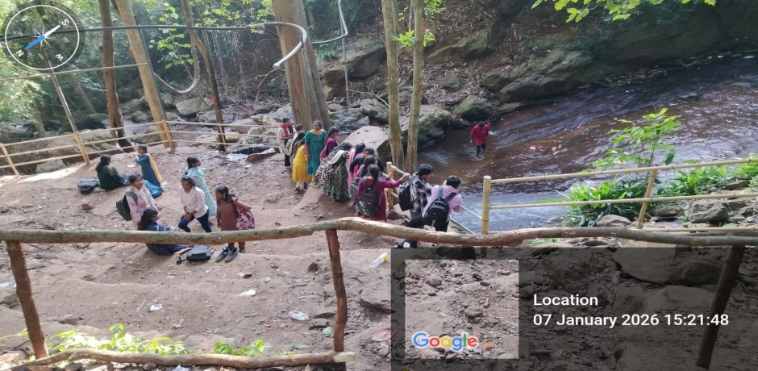 | 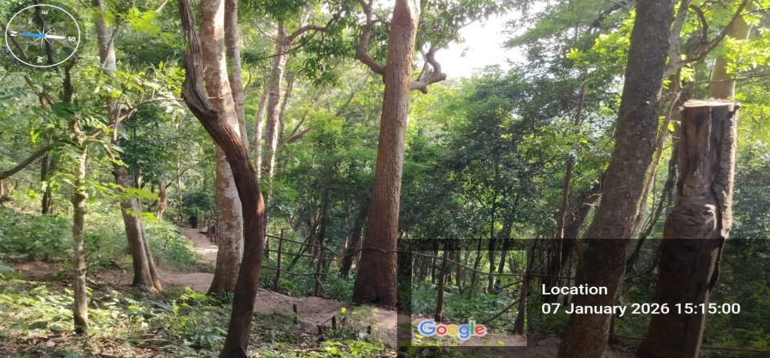
Amrutha Dhara Waterfall at Maredumilli is one of the most beautiful natural attractions in the Eastern Ghats and an important learning spot for B.Com students during field visits. Surrounded by dense forests and rocky landscapes, the waterfall attracts tourists throughout the year, making it a good example of eco-tourism development. The natural setting highlights how tourism can generate income while preserving the environment.
For B.Com students, Amrutha Dhara Waterfall offers practical understanding of tourism management, local entrepreneurship, employment generation, and sustainable business practices. Small stalls, guided services, and maintenance activities around the waterfall show how local communities participate in economic activities. The visit helps students relate commerce concepts such as resource utilization, cost–benefit analysis, and social responsibility to real-life situations, making learning meaningful and experiential.

GIRIJANA PRIMARY CO OPERATIVE MARKETING SOCIETY
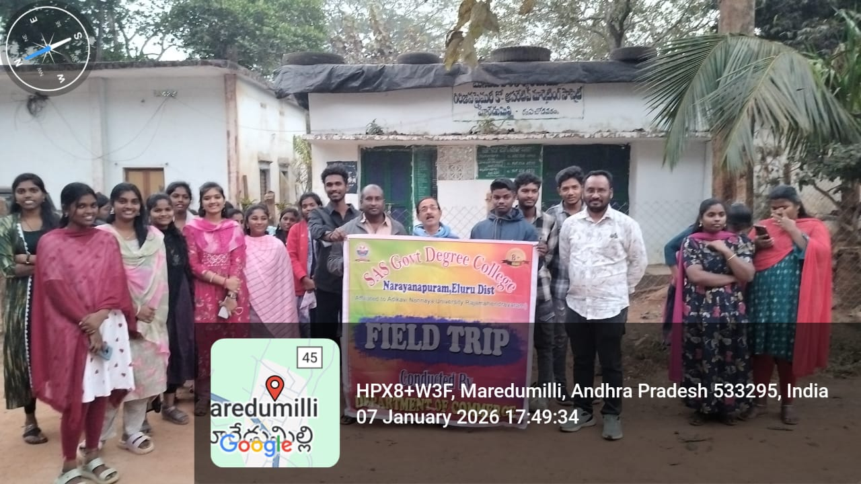 | 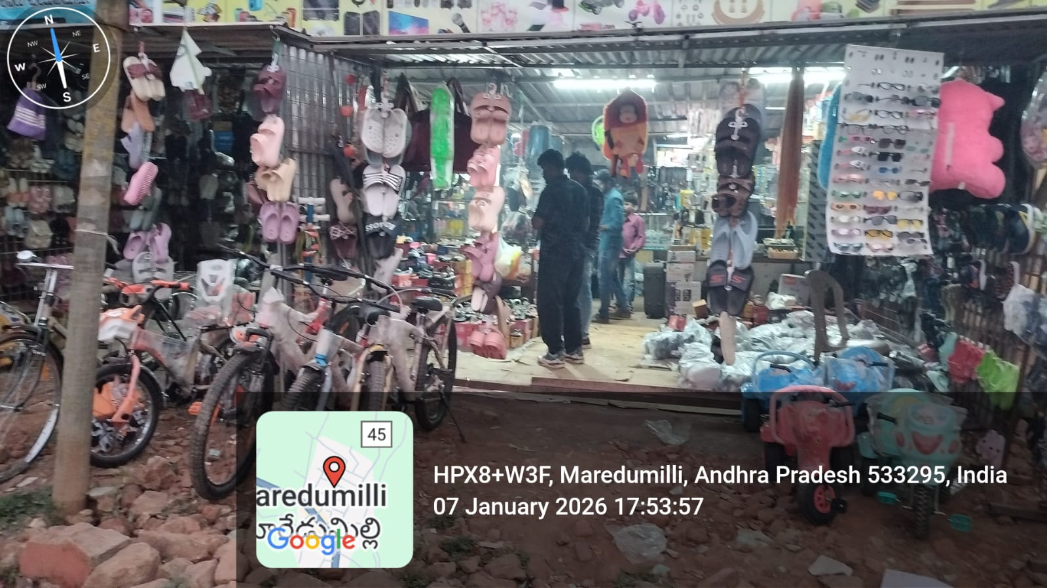
In the forest-covered hills of Maredumilli, the GIRIJANA PRIMARY CO OPERATIVE MARKETING SOCIETY
stands as a bridge between tribal life and organized markets. Long ago, the tribal communities depended on middlemen to sell forest produce, often receiving unfair prices for their hard work. Realizing this challenge, the Girijana Corporation Marketing Society was established to protect the interests of Girijanas and ensure fair trade.
At the Maredumilli center, tribal people bring honey, tamarind, turmeric, millets, and other minor forest produce to the society. The society collects, processes, and markets these products at fair prices, empowering tribal families economically. For students visiting the area, the society becomes a living lesson in cooperative marketing, ethical business practices, and inclusive growth. The Girijana Corporation Marketing Society at Maredumilli thus symbolizes dignity, self-reliance, and sustainable development rooted in community strength.

FIELD TRIP QUESTIONNAIRE & FEEDBACK
Maridumilli & Rampachodavaram
B.Com & B.Sc Students

SET – 1: Rural Economy  Questionnaire  - What is rural economy?  Answer: Economic activities in villages mainly based on agriculture and allied sectors.  - What are the major occupations in rural areas?  Answer: Agriculture, livestock, fishing, and small businesses.  - What resources support rural economy?  Answer: Land, water, forests, and human labor.  - What is the role of small businesses?  Answer: They provide employment and income to rural people.  What problems are faced in rural areas?  Answer: Lack of infrastructure, finance, and market access | Feedback  - Did you understand rural economic activities?  Answer: Yes, clearly understood.  - Was the field visit helpful?  Answer: Yes, very useful.  - Were the observations interesting?  Answer: Yes, highly interesting.  - Did you interact with local people?  Answer: Yes, interaction was informative.  - Overall experience rating?  Answer: Excellent.

✅ SET – 2: Tribal Economy  Questionnaire  - Who are tribal people?  Answer: Indigenous communities living close to forests.  - What are their main livelihoods?  Answer: Forest produce collection, agriculture, and crafts.  - What is forest dependency?  Answer: Dependence on forests for food and income.  - What challenges do they face?  Answer: Poverty, lack of education, and healthcare.  - How can their livelihood improve?  Answer: Through education and government support. | Feedback  - Did you learn about tribal life?  Answer: Yes, gained good knowledge.  - Was the visit informative?  Answer: Yes, very informative.  - Did it change your perception?  Answer: Yes, positively.  - Was guidance provided properly?  Answer: Yes, well guided.  - Overall satisfaction?  Answer: Very satisfied.
✅ SET – 3: Eco-Tourism  Questionnaire  - What is eco-tourism?  Answer: Responsible tourism in natural areas.  - What are its benefits?  Answer: Environmental protection and employment generation.  - Name eco-tourism activities.  Answer: Trekking, nature walks, wildlife observation.  - What is sustainable tourism?  Answer: Tourism without harming nature.  - How can we protect nature?  Answer: Avoid pollution and conserve resources. | Feedback  - Did you understand eco-tourism?  Answer: Yes, clearly understood.  - Was the environment clean?  Answer: Yes, well maintained.  - Did you enjoy the trip?  Answer: Yes, very much.  - Was learning practical?  Answer: Yes, very practical.  - Overall rating?  Answer: Excellent.

✅ SET – 4: Local Business & Marketing  Questionnaire  - What are local businesses?  Answer: Small businesses operating in a local area.  - Give examples observed.  Answer: Handicrafts, bamboo products, small shops.  - What is rural marketing?  Answer: Marketing in rural areas.  - What are marketing challenges?  Answer: Transport and communication issues.  - 5.How can businesses grow?  Answer: Through promotion and support | Feedback  - Did you observe business activities?  Answer: Yes, clearly observed.  - Was it useful for commerce learning?  Answer: Yes, very useful.  - Did you gain practical exposure?  Answer: Yes, significantly.  - Was faculty support good?  Answer: Yes, excellent.  - Overall experience?  Answer: Very good.
✅ SET – 5: Learning Outcomes  Questionnaire  - What is experiential learning?  Answer: Learning through experience.  - What skills were developed?  Answer: Observation, communication, teamwork.  - Why are field trips important?  Answer: They provide practical knowledge.  - What did you learn overall?  Answer: Rural economy and eco-tourism concepts.  5.How can this help in future?  Answer: Improves understanding and career skills | Feedback  - Was the trip well organized?  Answer: Yes, very well organized.  - Did you achieve learning objectives?  Answer: Yes, fully achieved.  - Would you recommend such trips?  Answer: Yes, definitely.  - Any suggestions?  Answer: More such trips should be conducted.  - Overall rating?  Answer: Excellent.

THANK YOU MADAM/SIR

